Mechanical waves – worksheet 2
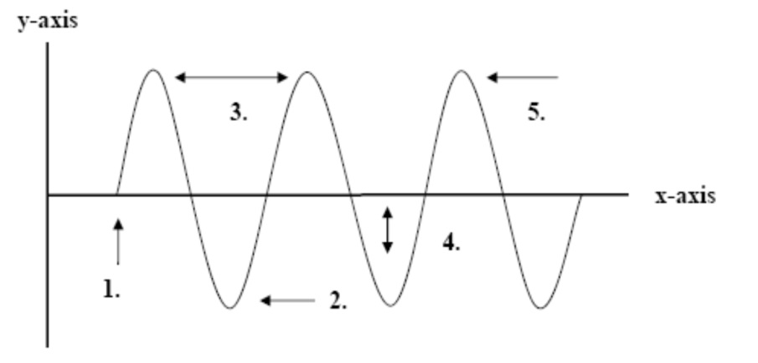
- The illustration below shows a series of transverse waves. Label each part in the space provided.
  - ……………………………..
  - ……………………………..
  - ……………………………..
  - ……………………………..
  - ……………………………..

- Fill in the blanks:
  - Waves carry ……………………… from one place to another.
  - The highest point on a transverse wave is the …………………….. while the lowest part is the …………………………
  - The …………………………. is the height of the wave.
  - The distance from one crest to the next is the ……………………………..

- Below are a number of series of waves. Underneath each diagram write the numbers of waves in the series.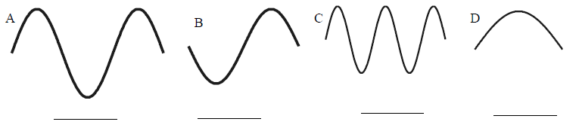
  - Which of the above has the biggest amplitude? ……………
  - Which of the above has the shortest wavelength? ….……
  - Which of the above has the longest wavelength? …………

- Match each definition with the correct term. Terms: longitudinal wave, trough, mechanical wave, medium, surface wave, rarefaction, transverse wave.
  - ……………………………… = disturbance in matter that transfers energy from place to place
  - ……………………………... = part of a longitudinal wave where particles of the medium are spread farthest apart
  - ……………………………... = wave in which particles of the medium vibrate at right angles to the direction that the wave travels
  - ……………………………… = combined transverse and longitudinal wave
  - …………………………….. = part of a transverse wave where the particles of the medium are lowest.
  - ……………………………. = wave in which particles of the medium vibrate in the same direction that the wave travels
  - ……………………… …… = matter through which a mechanical wave travels.

- Express the relationship between
  - Period and frequency ……………………………
  - Wavelength and frequency……………………
  - Wavelength and period ………………………..

Consider a wave generator that produces 10 pulses per second. The speed of the wave is 300 cm.s⁻¹.
  - What is the wavelength of the waves?

  - What happens to the wavelength if the frequency of pulse is increased?

- The wavelength of a sound wave in the room is 1.13 m and the frequency is 301 Hz.
  - What is the speed of the wave?

  - If you double the frequency of the sound wave, determine its speed.

  - What happens to the wavelength if you cut the frequency in half?

- State the units of the following quantities
  - frequency
  - intensity of the wave
  - intensity level

