Mechanical oscillations
Mechanical and electromagnetic oscillations and wave motions are widespread types of motion, for example sound and light. The term ………………………… is used precisely to describe ……………………………………….. Familiar examples of oscillation include a swinging pendulum and alternating current.
Mechanical and electromagnetic oscillations and waves are of course different, but they have a similar .............................................. and they follow similar rules.
Mechanical oscillation is the repetitive variation, typically in time, of some measure about a central value (often a point of equilibrium) or between two or more different states.
The oscillating body is called ........................................ Its motion state is determined by:
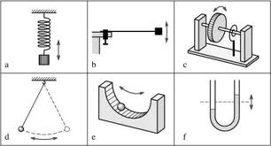
- an instantaneous position (displacement from the equilibrium position)
- an instantaneous ………………..
- an instantaneous acceleration

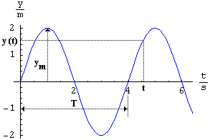
The oscillogram is a graph of the dependence of …………………………………………………… on time. It is actually its time record.
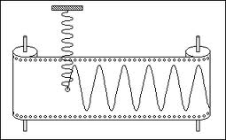
Mechanical oscillations can be ………………………………………. (most of the vibrations in nature (e. g. earthquakes, …………………………..)) and periodic. Periodic oscillations can be harmonical (the oscillogram is a sinusoid) and non-harmonical (e. g. vowels).

Mechanical oscillations
Mechanical and electromagnetic oscillations and …………………………… are widespread types of motion, for example …………………………………... The term vibration is used precisely to describe mechanical oscillation. Familiar examples of oscillation include a swinging pendulum and …………………………………………..
Mechanical and electromagnetic oscillations and waves are of course different, but they have a similar mathematical description and they follow similar rules.
Mechanical oscillation is the ………………………………, typically in time, of some measure about a central value (often a point of……………………………) or between two or more different states.
The oscillating body is called an oscillator. Its motion state is determined by:
- an instantaneous ………………… (displacement from the equilibrium position)
- an instantaneous speed
- an instantaneous …………………………………

The oscillogram is a graph of the dependence of the displacement of the oscillator on time. It is actually its ………………………………………….
Mechanical oscillations can be non-periodic (most of the vibrations in nature (e. g. earthquakes, consonants)) and periodic. Periodic oscillations can be ……………………………… (the oscillogram is a …………………………………..) and non-harmonical (e. g. vowels).

