Movie making Lab
2-day movie-making seminar at the WISA 1st Transnational Meeting in Greece

Author: | Ms Vasiliki Maltasoglou  The Balkans Beyond Borders NGO, Greece

Movie making Lab, powered by Ms Vasiliki Maltasoglou
The Balkans Beyond Borders NGO

The first day of shooting on a movie set is never the first day that film is being produced. Days, and sometimes weeks, months, years, or decades can go by from the beginning of a film’s inception to when cameras just start rolling.
The production and subsequent post-production processes of a movie can be shorter, longer, or about the same, but neither can exist without pre-production—the work that goes into a film before any images are recorded.
- Pre-production e.g. script breakdown, casting, production design, location scouting, set & costume design
- Production: directing, choreography, cinematography, lighting, sound mixer
- Post-production: editing, sound, music composer, color correction

Finalize a Shooting Script
While movies are magical, they don’t come out of thin air. Even before the pre-production process starts, you need an idea, and often a fairly polished screenplay to work off of. But when it’s crunch time, you need to finalize that screenplay and convert it to a shooting script—one that reads for the director, cinematographer, and camera crew as well as it does for the actors. Tweaks and whole scenes may be edited, added, or deleted at anytime (sometimes even in post-production!) but for the most part your shooting script should be ready to shoot by the time the director first calls action.

Storyboards & Shot Lists
Storyboards & shot lists go hand-in-hand with shooting scripts—creating a visual interpretation of the screenplay for the director and cinematographer to reference and prepare for. While some directors know exactly what they want in their hand and can draw it themselves, usually storyboard artists are hired to bring the story to life. Once a film is seen—even in black-and-white sketches—it comes alive in a way that the entire crew can see and gives them a concrete vision to strive for.

Find the Right Crew
While some crew positions might already be attached or recommended for a project, and other positions, like your writer and storyboard artist, could be hired very early in the process—you should work to get the entire team rounded out before pre-production gets too involved. After all, these are the women & men who will be carrying out a lot of these tasks, and the sooner they are involved in the creative process, the more valuable their input will be. All of filmmaking is a collaboration—not just the shooting!

Location Scouting
You may need to tailor your storyboards to your location or vice-versa, so finding them early is key. Many hands-on producers & directors may want to do this themselves, but often the smartest thing to do is hire a professional location scout who already has locales in mind or knows how to find original ones perfect for your script. If you’re shooting in a studio or soundstage, you’ll want to find the right one early and make sure it’s not booked before you can lock it in—treat them as you would reception halls for your own wedding! Finding real world locations early is just as important because you’ll want enough time to process the necessary permits & paperwork.
Create a Proper Budget (and Stick to It!)
By now you should be finalizing your budget, to make sure you can find the gear and afford the locations you want to use. Sometimes this is the professional thing to do; sometimes it’s the necessary thing to do because you’re not working with any credit or financial backers willing to give any more than they already promised. This is never the most fun part of pre-production, but very often it’s the most important.

Choose Your Gear
Are you shooting digitally or going old school with some 16mm film? Or are you saving money and shooting the entire film on your iPhone? Once you have the answers to these questions you can acquire your gear—often from a rental house. After your first film you may establish a relationship with a particular rental house and can negotiate discounts and figure out just exactly what your budget will allow when it comes to peripheral equipment. Maybe you can afford that ultracool fog machine after all!

Clear That Red Tape
Once you know what gear and locations you want, you’re going have to get into the paperwork—namely, permits and insurance. Permits are required from municipal governments to shoot on public property and location agreements are typically needed for use of private homes—especially if you’ll need to move furniture or equipment around or repaint the walls after the shoot, etc. You’ll also need insurance to protect yourself in the event you or one of your crew members accidentally do damage to the location or your rented film equipment. Finally you may need to cover your crew and cast as well—better safe than sorry!

Find the Right Cast
With your dominos falling in place you’re going to need to finally decide on your cast—this could feel impossible, no matter how many actors your audition. You might be frustrated you can’t find the perfect person for the role you envisioned in your head, or maybe you found two equally brilliant performers and you’re pulling your hair out trying to decide between the two. Either way, auditioning early and often and even employing a casting agent to find even more performers, possibly from outside your locality, will go a long way towards giving your movie the perfect cast.

Rehearse, Rehearse, Rehearse
Sometimes finding the perfect cast could make a filmmaker overconfident, leading them to put too much responsibility on their cast to be self-sufficient. Actors need their director just as much as the crew does, and working with them both one-on-one and as an ensemble is a vital part of the pre-production process. Holding table reads and rehearsals weeks before shooting will ensure that when the camera is ready to the roll, your cast will be giving the performance your movie truly needs. This extra time before the shoot also allows the cast to develop a genuine chemistry that will not go unnoticed by your audience.
These are just nine simplified stages of a complex, multifaceted pre-production process. Just remember that if you’re confident and prepared you can get through any hurdle and tell the story you’ve always wanted to tell. So the best way to get through pre-production is to learn the skills first and then master them with experience and resolve.

The six stages of film production
1. Development
The start of a project varies, but generally will begin with development of a script, be that an existing script, a book, a brief story outline. Development may also start with a Director and/or Writer pitching an idea to a Producer.

2. Pre-Production
This is the phase where you would narrow down the options of the production. It is where all the planning takes place before the camera rolls and sets the overall vision of the project. Pre-production also includes working out the shoot location and casting. The Producer will now hire a Line Manager or Production Manager to create the schedule and budget for the film.
Pre-production is a fairly loose term which refers to the tasks undertaken before production begins. Exactly what is included in this stage depends on the medium and situation.
For a small video company, pre-production may refer to everything that happens before shooting begins, for example, meeting with the client, research, storyboarding, location planning, etc.
For feature films, pre-production is more specific and only begins when other milestones have been met such as financing, screenplay, casting. In this case pre-production includes:
- Location scouting
- Prop and wardrobe identification and preparation
- Special effects identification and preparation
- Production schedule
- Set construction
- Script-locking (semi-finalisation of the script)
- Script read-through with cast, director and other interested parties

3. Production
During this phase it is key to keep planning ahead of the daily shoot. The primary aim is to stick to the budget and schedule. Communication between all parties is crucial during the shoot and the production must maintain a full set of records and have to remain on time and on budget.
In film and video, production refers to the part of the process in which footage is recorded. This is when the camera rolls. This is what most people imagine when they think of a film being made — actors on sets, cameras rolling, etc. (The production phase is also known as principal photography).
It is nearly always the most expensive phase of film production, due to actor, director, and set crew salaries, as well as the costs of certain shots, props, and on-set special effects. Everything that has happened up to this point is to make principal photography go as smoothly and efficiently as possible.
The goal of principal photography is obviously to record all required shots, however it is fairly common to shoot "pick-up" shots in post-production. Pick-up shots may be required when a mistake is noticed, a script change is made (this is unusual), or even if a performance is deemed to be unsatisfactory.
In music, production usually refers to the creative direction of a project. Unlike a film producer who is more of a manager, a music producer has a very hands-on role in the creative development.
In large feature films the beginning of the production phase marks the "point of no return", i.e. the point at which it is no longer financially viable to cancel the project. At this point it is almost always cheaper to continue until the project is finished than to deal with the financial fall-out of canceling.

4. Wrap
The period immediately after shooting ends. It is when we strike (dismantle) the set and clear the location. Everything must be returned in good order to suppliers and there must be a full set of records of the shoot.

5. Post-Production
This stage starts when principal photography ends, but they may overlap. The bulk of post-production consists of reviewing the footage and assembling the movie - editing. There will be contributions as required from Visual Effects (VFX), Music and Sound Design.
Post-production is the third and final major phase of the production process. It is often referred to simply as post, e.g. "We can sort that out in post".
- Editing video footage
- Editing the soundtrack, adding sound effects, music, etc.
- Adding titles and graphics
- Color and exposure correction
- Adding special effects
- Re-shooting certain scenes if required ("pick-up" shots)
In most cases however, post-production is a time-consuming job taking longer than the actual production phase.

6. Distribution
Once the film is completed, it must be distributed. This is how producers make their money back and a considerable amount of time and energy will be invested to secure the right distribution deals for their projects. The film will go into the cinema and/or be distributed via various platforms such as Amazon Prime, Netflix, and HBO etc.

BASIC CAMERA MOVES
PAN LEFT/PAN RIGHT / WIP PAN
FEELS LIKE I WANT TO SEE SOMETHING / THE WIP PAN / FAST PAN CREATS ENERGY
SLOW PAN GIVES TIME TO GO IN THE LANDSCAPE
Panning is when the camera is moved horizontally from one side to another on a central axis. This is a rotating movement in which the camera’s position remains in place, but the direction that it faces changes. It can be used to follow a moving character or to fit more into a frame, for example, panning across a landscape to create a sense of place. These types of shots are great for establishing a sense of location within your story.

TILT UP/TILT DOWN
MAYBE THE MOST EFFECTIVE OPENING SCOTS IN HISTORY
IT REVEALS SOMETHING TO US
REDIRECTING OUR ATTENTION
Tilting is similar to panning in that the camera is kept in a stationary position, but unlike panning (which looks from side to side) tilting focuses on upwards & downwards movements. Using a tilting motion helps to fit more into a single frame. A slow upwards tilt can be very effective in making a subject appear bigger or more significant while a downwards tilt has the opposite effect. These shots are popular when introducing a character, especially one of grandeur, in a movie.

ZOOM IN /ZOOM OUT
Probably the most well-known camera move, zooming gives the impression of moving closer or further away from the subject. It can be used effectively to magnify a certain focus point in the frame, but other moves such as a dolly, are a more natural way to show movement.
While a quick zoom can help add a sense of drama and energy when used correctly, avoid over-using zoom as your default move. It is often used as a clutch when the videographer is not sure what else to do to add interest to a shot. If you are going to use zoom, try to use it creatively. Zoom in or out from an unexpected, yet important, object or person in your shot. Use a quick zoom to add energy to a fast-paced piece. Don’t get stuck with your zoom as your default move.

DOLLY
A dolly shot is when the entire camera is mounted on a track and is moved towards or away from a subject. A dolly is when you move the entire camera forwards and backwards, typically on some sort of track or motorized vehicle.
Unlike a zoom shot, the world around the subject moves with the camera. A dolly gives the illusion that the viewer is walking towards the subject and can be a great way of creating a sense of intimacy between them.

TRUCK
Similar to dollying, trucking involves moving the entire camera along a fixed point, but the motion goes from side to side, rather than in and out. It’s often used to follow characters in action. Mounting the camera on a fluid motion track will help to stamp out any jerking or frixion camera movements.

VERTIGO
COMBINES ZOOM AND DOLLY

CRANE OR BOOM
When the camera is attached to a crane. The shot is done from a camera operator or it can be done remotely.

STEADYCAM
A device that enables smooth video shooting by stabilizing a camera and isolating it from shock and vibration.

HANDHELD
A technique in which a camera is held in the cameras operator hands as opposed to being mounted in a tripod.

PEDESTAL
A pedestal (AKA Boom up/down or Jib up/down) involves moving the camera upwards or downwards in relation to a subject. It’s different from tilting in that the entire camera ascends or descends, rather than just the angle of the camera. A pedestal shot can be used to frame a tall or high subject (such as a building) while keeping the framing at eye level view for the viewer.

RACK FOCUS
Rack focus is not as much of a camera move as it is a technique, but many amatuers overlook this essential skill. You adjust the lens to start an image blurry and then slowly make it crisper, or vice versa. It is an extremely effective way for you to change your audience’s focus from one subject to another.

STORYBOARDING SHOT TYPES
There are many ways to frame a subject within a shot, which can range from showing their entire body to fixating on a finer detail, such as their eyes. In choosing the most fitting shot, you’ll need to bear in mind the message that you’re trying to communicate to your audience.

HOW EVER YOU CHOOSE TO MOVE THE CAMERA
THE REAL OBJECT YOU SHOULD BE FOCUSED ON MOVING IS YOUR AUDIENCES ATTENTION.
THING ABOUT WHAT YOU WANT THE AUDIENCE TO FOCUS ON IN EACH SHOT AND WHY IT SERVES THE STORY.
THEN THINK ABOUT WHAT DEVICES AND MOVEMENTS CAN HELP YOU ACHIVE THEM

Here are some of the most common types of shots and how you can go about using them:

CLOSE-UPS FRAMING
CLOSE-UP SINGLE
MEDIUM CLOSE-UP TWO SHOT
EXTREME CLOSE-UP THREE SHOT
WIDE CLOSE-UP OVER THE SHOULDER
OVER THE HIP
LONG SHOTS POINT OF VIEW
WIDE SHOT
EXTREME WIDE SHOT DUTCH ANGLE / TILTED SHOT
DUTCH LEFT
FULL SHOT DUTCH RIGHT
MEDIUM FULL SHOT
LONG SHOT FOCUS / DOF (DEAPTH OF FIELD)
EXTREME LONG SHOT RACK FOCUS
SHALLOW FOCUS
MEDIUM SHOTS DEEP FOCUS
MEDIUM SHOT TILT-SHIFT
CLOSE SHOT ZOOM
MEDIUM CLOSE SHOT

CAMERA HEIGHT
EYE LEVEL
LOW ANGLE
HIGH ANGLE
OVERHEAD
SHOULDER LEVEL
HIP LEVEL
KNEE LEVEL
GROUND LEVEL

Establishing shot
Often included at the beginning of a scene, the establishing shot helps to build ambiance and may give a nod towards the context of what’s to come. It generally comes in the form of a long shot and indicates where (and sometimes when) the scene is taking place.

Full shot
The full shot is just as the name implies and shows the entire body of the subject from head to toe. This shot tends to focus more on the character’s movement and gestures, rather than their state of mind.

Medium shot
Also known as the ¾ shot, the medium shot typically shows the subject from the knees up. It allows the viewer to see the background environment and the character’s gestures, while still being close enough to capture their emotions.

Close shot
With a close shot, the subject’s head/face takes up the majority of the frame and therefore, allows their reactions and emotions to dictate the scene. The subject becomes the prominent focus and helps the audience build a personal connection, without being distracted by background interferences.

Extreme close shot
An extreme close shot is so close that only one specific detail, such as a person’s eyes or mouth, can be seen. Because of the unnaturally close nature of the shot, it should be used sparingly, but when used appropriately, an ECS can be incredibly effective at adding drama to a scene. It allows the viewer to see details that may have otherwise gone unnoticed and can really accentuate the emotions that the subject is experiencing.

Up shot
An up shot is taken from below the eye-level of the subject and creates the perception that the viewer is looking at them from a lower perspective. This type of shot can give the impression that the subject is in some way powerful, heroic or even dangerous.

Down shot
A down shot, in contrast to an up shot, is taken from above the eye-level of the subject and can make the subject seem vulnerable or powerless.

Over the shoulder shot
This type of shot is taken from behind the shoulder of another character and typically frames the subject in a medium or close shot. It is particularly effective in group conversation scenes and helps establish which characters are speaking to each other.

Two shot
A two shot presents two characters together within the same frame. It’s a natural means of introducing both people and can be used to shed light on their relationship with one another. Different variations of the two shot can be applied to deliver different messages about the characters. For example, when characters are positioned next to each other, it may give the impression that they have equal prominence within the scene.

Point of view shot(POV)
The point of view shot, also known as the POV shot, depicts an angle that shows what a character is looking at. This type of shot allows the viewer to take on the perspective of the character and begin to understand their state of mind on a more personal level.

LIGHTING 3 point lighting
CHARACTERISTICS OF LIGHT
1)DIRECTION
2)COLOR
3)QUANTITY
4)QUALITY

1.KEY LIGHT
45 DEGREES FROM THE CAMERA CREATS SHADOWS MAKING THE SUBJECT APPEAR MORE 3DIMESSIONAL.
A key light is the primary light of the scene. It will be the most intense and direct light source of the entire scene. It will be the first light to set up, and will be used to illuminate the form of the subject or actor.
Key Points:
Avoid placing your key light close to the camera. It will cause your lighting to become flat.
A key light is the primary light in a three-point lighting setup.

SHADOWS=DEPTH=CINEMATIC
PLACING KEY LIGHT TO HIGH WE HAVE RACOON EYES.
PLACING KEY LIGHT TO LOW WE HAVE SCARY EFFECT THRILLER.
FLAT LIGHTING=DIRECT LIGHT=CAN SEE EVERY DETAIL, NO DIMENSIONS NO SHADOWS.
PARAMAOUNT LIGHTING=LITTLE SHADOW UNDER THE NOSE MOSTLY APPLIED ON WOMEN.
LOOP LIGHTING=THE SHADOW CREATES A LOOP ON THE CHIC HELPS FACE LOOK SLIMER AND LONGER.
REMBRANT LIGHTING = 45 DEGREES FROM CAMERA THE NOSE SHADOW CONNECTS WITH CHEEK SHADOW.
KNOWN FOR CREATING A TRIANGLE OF LIGHT ON THE CHEEK SUBJECT, MAYBE THE MOST POPULAR PATTERN USED IN HOLLYWOOD FILMS.
SPLIT LIGHTING = 90 DEGREES FROM THE SUBJECT SPILTS THE FACE IN HALF= DRAMATIC LOOK.

2.FILL LIGHT
A fill light illuminates the shadows that are created by the key light. A fill light is usually placed on the opposite side of the key light, and often not as powerful as the key.
Key Points:
As the primary function of the fill is to remove shadows created by the key, it’s important that the fill remains indistinctive and does not create shadows or it’s own characteristics. The closer the fill light is to the camera, the less shadows it will create.
Fills are easy to create even if you don’t have another light at hand; you can place a reflector on the opposite 3/4 to the key. Light will spill onto the reflector and bounce up to your subject.

3.BACK LIGHT
A back light hits an actor or object from behind, and is usually placed higher than the object it is lighting. A backlight is often used to separate an object or an actor from a dark background, and to give the subject more shape and depth. Backlighting can help bring your subject out and away from looking two dimensional.
Key Points:
Non-diffused sunlight can often be too harsh to light your subject as a key light, but as a backlight, the sun can make your subject stand out.
With the sun as a backlight, you can use a reflector or a foam board to bounce the sun at a lesser intensity back up to the actor.
To create a silhouette, expose for the backlight and remove your key and fill.
If a backlight is placed behind an actor at a directional angle, where the light hits part of the face, the backlight becomes a kicker.

NATURAL AVELIABLE LIGHT DAY / NIGHT
BOUNCH LIGHT
HIGH KEY LIGHTING : THE MORE FILL LIGHT YOU USE THE LESS CONTRAST YOU HAVE = COMEDY / COMERCIALS / ROMANCES
LOW KEY LIGHTING : MORE CONTRAST= MORE DRAMATIC SENARIOS, MORE CINEMATIC DUE TO THE ADDED DEPTH IT GIVES YOUR SUBJECT.
HARD LIGHTING
SOFT LIGHTING
RIM LIGHTING
SILUETTE LIGHTING
PRACTICAL LIGHT : A practical light is an actual working light within the scene itself. This can be a household lamp, a TV, candles, police lights and so on.
MOTIVATED LIGHTING : Motivated lighting is when the light in the scene imitates a natural source within the scene. The difference between motivated lighting and practical lighting is that motivated lighting is the act of enhancing and replicating practical lighting.

CUTS AND TRANSITIONS

1.CUTTING ON ACTION = CUTTING FROM ONE TO ANOTHER WHILE THE SUBJECT IS STIL IN MOTION (E.X. PUNCH, KICK, A CHARACTER TURNING,THROWING SOMETHING, CHARACTER GOING THROUGH A DOOR.

2.CUT AWAY = INSERT OF SOMETHING AND BACK
TO GET INSIDE THE HEAD OF A CHARACTER

3.CROSS CUT = WHEN THE EDITOR INTERCUTS BACK AND FORTH BETWEEN LOCATIONS (PHONE CONVERSATIONS AND WHEN USE EFFECTIVLY CAN CERTAINLY AMP UP THE TENSION AND SUSPENSE OF A SEQUENCE)ALSO USED TO SHOW WHAT IS INSIDE THE CHARACTERS HEAD

4.JUMP CUT = CUT BETWEEN THE SAME SHOT
YOU CAN SHOW THE PASSING OF TIME
ADD A LEVEL OF URGENCY ON THE SCENE

5.MUTCH CUT = CUTS FROM ONE SHOT TO SIMILAR SHOT BT EITHER MATCHING THE ACTION OR THE COMPOSITION

TRANSITIONS
1.FADE IN / FADE OUT = DISSOLVING EITHER TO, OR FROM BLACK

2.DISSOLVE = WHEN YOU BLEND ONE SHOT TO ANOTHER
YOU CAN SHOW THE PASS OF TIME

3.SMASH CUT = SUDDEN TRANSITION
WEAKING UP FROM A NIGHTMARE, OR AN INTENSE DREAM
GOING FROM SOMETHING INTENSE TO QUIET OR QUIET TO INTENSE

4.IRIS CUT = WHEN YOU CLOSE THE IRIS OF THE LENS
NOW IT IS USED IN THE SCENE

5.WIPE = WIPE LEFT , WIPE RIGHT…

6.INVISIBLE CUT = IS USED TO GIVE THE IMPRESSION OF A SINGLE TAKE,
A)CUT INTO BLACKNESS,
B)WHIP-PANS ALSO CAN HIDE A CUT IN THE CAMERA MOVEMENT.
C)AN OBJECT CROSSING THE FRAME OR WHEN AN OBJECT LEAVES THE FRAME

7.L-CUT = AUDIO BASED TRANSITION
A)WHEN THE AUDIO FROM THE CURRENT SHOT CERRIES OVER TO THE NEXT SHOT, DOESN’T HAVE TO BE FOR SCENE TRANSITIONS.

8.J-CUT = WHEN THE AUDIO FROM THE NEXT SCENE STARTS BEFORE YOU GET TO IT. YOU HEAR WHATS GOING ON BEFORE YOU SEE WHATS GOING ON.
SOUND / MUSIC

A sound utility is one of the puzzle's most important pieces. Part of the production sound team that generally includes a production sound mixer, a boom operator, and a sound utility, they're often referred to as 2nd boom, third, or cable person
You will need to work with the location department at practical locations to make sure all extraneous noises can be shut off.
One of your most methodical and critical jobs on set will be to wire talent. You're working with actors, wardrobe and makeup/hair to make sure everyone is on the same page and understands what you're looking to accomplish. Having to stop production to fix an incorrectly placed lav is something every sound department wants to avoid.
Watch rehearsals and assist the boom operator as needed. Listen for noisy props and quiet them before shooting. Note if any plant or wireless mics will be needed to cover the scene.
Recording SFX on set or on a studio.

Shoot Dual System Sound
HDSLR cameras such as the Canon 7D are inexpensive yet provide amazing picture quality. What they don’t give you is decent sound recording. The attached microphones just are not equipped to give you anything but basic audio. Even if you purchase an external microphone to plug into the auxiliary jack, you will not be able to get proper placement of the microphone. In other words, the mic is simply pointing the same direction as the camera and from the same distance. This does not allow for control over sound recording.
Instead, you should purchase, rent, or borrow an external digital recorder. By using a field recorder, you can control microphone placement and volume.

Use the Proper Accessories
With the Tascam and Zoom field recorders, you can use their internal microphones or connect an external one. Depending on your budget, it is recommended that you use a directional shotgun mic and a boom pole. This allows you to move the mic in close to the actors and focus the recording on one particular source. If a professional boom pole is too expensive, simply affix the mic to a standard broom pole to provide you extended reach.
Other accessories you need to be aware of include headphones, XLR cables, and windscreens for your microphone. Properly assess your recording needs in pre-production and see what you can afford to buy. You can get away with certain cheaper alternatives such as using your phone ear buds in place of studio headphones, for instance. Lavaliere microphones can be a great replacement for boom mics in certain shooting situations, but they also bring about their own set of problems such as power source and inconsistent recording quality, so research the best microphone to do the job that is needed.

Include a Sound Recordist and Boom Operator on Your Crew
Most of the time, an experienced audio person can both record and boom, but a second member of the team is handy even if it’s another crew member doing double duty.

Scout Locations for Audio
During pre-production, have the audio team do a tech scout at each of your locations to listen for any potential problems you may encounter while recording sound during the shoot. For instance, listen for traffic noise, airplanes, trains, air conditioning, nature sounds, or anything else that might be distracting or problematic in editing. By addressing these issues in the planning stage, you will prevent wasted hours of filming and headaches in post production.

Be Aware of Your Levels
In order to record the best quality of sound, the volume needs to be at the highest level possible without being distorted.
You should also be wary of volume that is recorded too low. Your noise floor is the smallest measurement of sound and it’s where a lot of “garbage noise” exists, so the closer your recording is to that noise floor, the “dirtier” your audio is going to be. Remember that any problems you have recording while on-set need to be fixed in post production, which means that if you have to raise the gain in post in order to hear the actors, you’re also going to increase the background noise.

Be Aware of Mic Placement
If your microphone is too far away from your actor (such as on your camera shooting at a distance), the sound waves from your source take longer to reach the mic, thereby creating an “empty room” feel. It also forces you to increase the gain and pick up more background noise. Place the mic as close to the performer as possible just out of the frame.

Record Room Tone
No matter how careful you are in recording proper levels on each actor for each shot, when you get into the editing room, you’re going to have to do clean-up work, which means you may end up with the background audio at various volumes throughout your edit. To solve this problem, record a minute or two of room tone, or just the background noise with no one speaking at each of your locations. This will provide your sound editor an uninterrupted environment onto which to build the dialogue and sound effects and will make your film sound professional.

Record Camera Audio
No, because you’re not going to actually use the camera audio in your edit. It will be used for syncing purposes. Final Cut Pro X and Adobe Premiere, as well as programs such as PluralEyes, use audio waves from various sources to automatically sync all the elements, including multiple cameras. However, you must have audio recorded on your footage for this to work, otherwise your editor will be cursing you for having to manually sync every shot. Which brings us to—

Use a Slate and Proper Cadence
The main purpose of the slate is to provide visual information to the editor and to sync sound to picture through use of the clapboard. Even though editing programs may have the ability to match the actual audio waves from numerous files, a clap gives a distinctive sound pattern that makes it easier to sync. And if you end up having to sync manually, it will be a lifesaver as you can visually see when the stick connects with the board and match it with the beginning of the sound of the clap.
As for audio information, you need a camera assistant (or a crew member acting in this capacity) to call out the shot and take numbers. Get in the habit of using proper on-set commands. Your assistant director, who should be running the set, handles this routine:

Assistant director: “Quiet on the set/on location” (this notifies everyone that you are ready to film).
Assistant director: “Roll sound.”
Sound recordist (once audio is being recorded): “Rolling” or “speed.”
Camera assistant: “Scene _____ take _____.”
Assistant director: “Roll camera.”
Camera operator (once camera is recording): “Rolling” or “speed.”
Camera assistant: “Marker” (then claps using the slate).
Camera operator (when ready to begin filming the action): “Camera set.”
Director: “Action.”

Be Aware of What Audio Can Be Replaced in Post
Not all locations will give you prime audio recording options, so there will be times when you might have to do Automatic Dialogue Replacement (ADR, or “looping”), where you bring the actors back during post production to re-record their dialogue by lip syncing to the edited shots. However, this will give you a different sound quality than in your original location. Exteriors and interiors inherently sound dissimilar. Can you get the actors to match their lip movements and emotions exactly? Will the actors be available after the picture is edited? Don’t count on always “fixing it in post,” but rather try to get the cleanest sound on location as possible during principal photography.
Treat Audio with Respect
Finally, as a filmmaker, pay attention to your film’s audio needs as well as the visual ones. Sound design can add a whole other dimension to your final production that complements the cinematography, and approaching it in every stage of production as an important piece of the puzzle will elevate your work. Give it the proper care and attention that you would to lighting, casting, wardrobe, and every other element. Remember that no one notices good sound—it only stands out when it’s done poorly.

LIST OF ATTACHMENTS:
ATTACHMENT 1 – Lesson plan and timetable of activities
ATTACHMENT 2 – Storyboard Template
ATTACHMENT 3 – Types of shots
ATTACHMENT 4 – Camera shots and angles
ATTACHMENT 5 – Storyboard example

ATTACHMENT 1 – Lesson plan and timetable of activities
TELLING STORIES THROUGH FILMS

Who we are and what we have in common

Introduction of myself

Before we start, it would be good to get to know eachother better but also learn something about ourselves. So, in this paper I would like you to write your name using the colour that represents your feeling.
This way we will create a wall of feelings. After finishing the workshop you will come and write again your name in the colour that represents your feeling

Board of feelings
We create after a game a board of feelings with post its

Before they enter I have placed cartons with film production roles so that the created teams to represent an activity in film making:
Script writers | Actors | Producers | Editors | Sound designers
Directors of Photography | Cameramen | Directors | Musicians
Lighting/Sound

They take a sit according the role they got
Let’s find thigs in common
Do you like watching films?
Do you like talking about films?
Do you like making films?

We are all here today because we want to make films or even we do not want to make our own films or we just like films. In filming you do not have to be the one who is making the film, the director, you can be the one who imagined and wrote the story, the script writer, or you like photography, so you are the director of photography, you may love making sounds, so you deal with sound effects in film industry you will hear it as foley, you love music so you are the composer or sound designer, you can be the video editor and so on. What I want to say with this is that filming is a whole world of cooperation, teamwork and creation.

15 minutes

CHOOSING THE THEME

So, in order to make a good film at least we must have a story. And better said, a good story!!

But before we make our story there is something else behind. The story is just the means to talk about things that bother us or our society, things that we want to answer
For example, there is a boy who changes city because his parents can’t afford life in the big city and we see how is the new life of the boy. So, this is the story. But the reason we make this story is that we want to speak about crisis, or life in the village, or about being different or even about bullying etc.

So, before starting making our story we must be very sure about what we want to talk about. And this can be more than one thing.

Let’s see a movie!

What was this film about?
Can you identify the themes it raised?
Economic crisis, that life can be tough and we can’t have everything we want,
Airbnb

If we know what we want to talk about, then it is easier to find our story.

A theme can come out as result of something that is hot in the Media at a certain period of time, or an issue that bothers our society or something personal that happened in our life, a historical fact that interests us and so on and so on.

Would you like to create our special pool of themes? Each group can write two themes. It doesn’t matter if more than one groups write the same theme. This is important for me to know what bothers you. 1. One theme will be a theme that bothers your age and 2. The other will be a theme that concerns the world in general

Δινω σε καθε ομαδα δυο χαρτιά και γραφουν απο ενα θεμα το οποιο εχουν αποφασισει απο κοινου

25 minutes

THE STORY
There are many ways to tell stories and there is no golden recipe to tell a story. It is multidimensional. Of course what we surely want is to make a good story.
- And a good story must have a solid structure.
- And for sure we want to touch the audience so it is better to have a structure in our mind and not want to say everything without determination.
- We want the story to be done in such a way that will help us deliver our message to the audience and touch it.
- So it has to be well done and complete: without gaps or misunderstandings

The structure of a script
________ _________________________________ ________
BEGINNING MIDDLE END

30’ 60’ 30’
1’-2’ 4’ - 7’ 1’-2’

So in our film which is the beginning and where?
Which is the middle part?
Which is the end?
Which is the problem that our hero faces?

- For Aristotle, a story, an adventure is the journey from happiness to unhappiness and the other way round from unhappiness to happiness
- The story is a journey to a change
- In a story our hero learns something at the end a big true about himself. It is the journey from the ignorance to the knowledge
- In a story apart from the beginning which is an introduction everything that happens is interrelated. with a cause and effect. Every action affects the next one and every action has its reason in the action before.

So, first we introduce our hero or our background and a little before the end of the introduction we try to reveal what bothers the hero, what he/ she wants to answer for himself/ herself and then we enter the middle part of the film where our hero confronts the problems. Goal of a film is to answer the hero’s question doesn’t matter if question is answered we have happy end, when the question is not answered we have a bad end.

BOY - EXAMS - FOOTBALL

Our hero is a young girl living with her parents and she wants to have a romantic night with her boyfriend. All day she faces the problems of her everyday life and waiting for her boyfriend to come. When they meet the resolution of the conversation is not good and after his announcement her life will change completely.
It is a film where things start very positive but at the end everything goes bad

The biggest part of a film is when our hero confronts the problems or the problem and tries to solve it

10 minutes
________________________________________________

THE PROTAGONIST - THE HERO

As we said in the beginning through a film, we want to talk about an issue.
The best way to talk about this issues is to find a protagonist and let him do the job for us.
So, a subject becomes more interested when it gets a face.
Με τι κριτηρια επιλεγω τον πρωταγωνιστη
This person who will be our protagonist, must have these characteristics that will help our spectator to find the connection.
Through the story of one person we will learn the stories of many.
Examples with advertisements (Germanos) or the stories in social media (influencers)
QUESTION about advertisements

- The hero will carry the story on his shoulders,
- The hero will face the problems and he will have to find the solution.
- He is the spine of our story.
- The hero is he one who does the biggest journey in our film.

So who in our story is the protagonist?

As we do in cooking: before we start
We must have all the ingredients in front of us. Every ingredient is meaningless on its own but when they will get mixed in the pan we will have created one special dish.

- Characteristics of appearance
- Personal characteristics
- Societal situation
- Era
- Age
- Education
- Health
- Social class
- Life goals
- …..

Which are the characteristics of her? If we know that we have done half of our job
1.
2.
3.
……
Να πω για την εισαγωγη

This is how we work with our hero.
We must know everything about him or her (or almost everything)
What do you think it is important to know?
When I did a script writing seminar one of the tasks after having written some parts of our story, was to write a completely different scene in which we had to show the main characteristics of the personality of our hero regardless the script. It was a tough job but it helps you have a better understanding of what you want to talk about.

…………………

I will give you 15 minutes to decide which topic you would like to deal with and who your hero would be. You will write 7 characteristics

15 minutes
____________________________

Let’s go to action:

Our hero is his/ her actions not his / her words.
Tip: do not ever choose the easy way to say something in your film
Too much of speaking is tiring. The eyes of the spectator need action.
The hero may say: “when I see him, I ll tell him the truth” and when he sees his friend he doesn’t say a word. This is the truth for our her: that he wants to be honest but he is afraid.

Never use the mobile conversation to help the story go. Only if it is part of the thematic eg the new film Scopophilia that speaks about relations through internet so the biggest part of the film is in front of a PC screen.

For example, if two friends want to meet do not spend time by giving information through their conversation via mobile or worst through texts but better through their actions. It is more creative to see how life can be shown rather than said.
But if your hero is it by a car because he speaks on the mobile, of course you will use it.

And also it is better when you reveal things about your character. E.g if he is racist do not let him say I am racist but show it!!!!

Campel’s hero

15 minutes
__________________________________________

Let’s go to create your own stories

- You will pick up a topic of those in the pool
- Then you will write who the protagonist is
- What happens to him/her
- Some characteristics he/ she has (short BIO)
- Introduction
- Facing the problem
- Solution
- Finding of a title

30 minutes
____________________

DEBRIEFING
One representative of each group tells the story

VOTING TIME!!!
Each group gives 2 votes
30’
_________________

- Pre-production e.g. script breakdown, casting, production design, location
scouting, set & costume design
- Production: directing, choreography, cinematography, lighting, sound mixer
- Post-production: editing, sound, music composer, color correction

Production: Communication between parties is the most important
Footage of all scenes scheduled before
Shoot everything and all required shots. changes can happen during editing process and post production
WRAP (τελος)

Επιλογή σκηνής
Shooting list & story board
Story boarding shot types

Camera moves

Lighting
Three way lighting (key light, fill light, back light
Σκιες cinematic effect

ATTACHMENT 2 – Storyboard Template

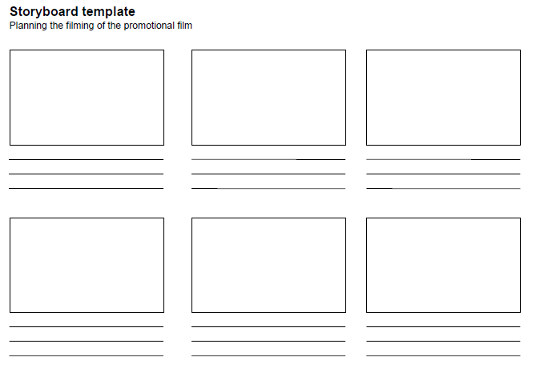

ATTACHMENT 3 – Types of shots

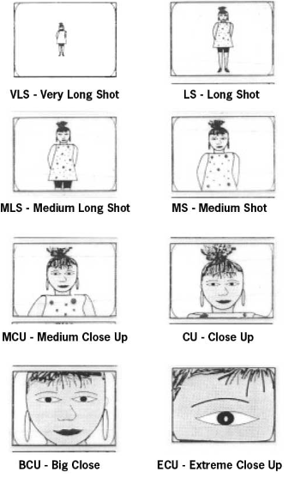

ATTACHMENT 4 – Camera shots and angles
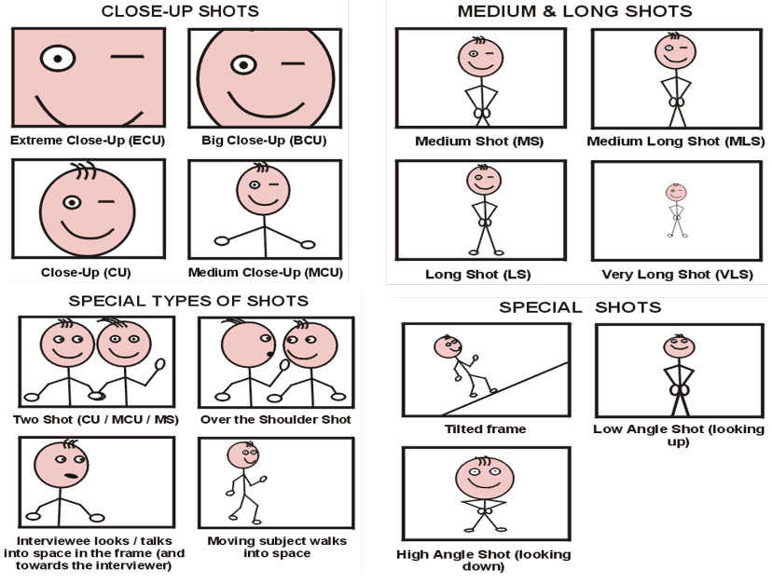
ATTACHMENT 5 – Storyboard example

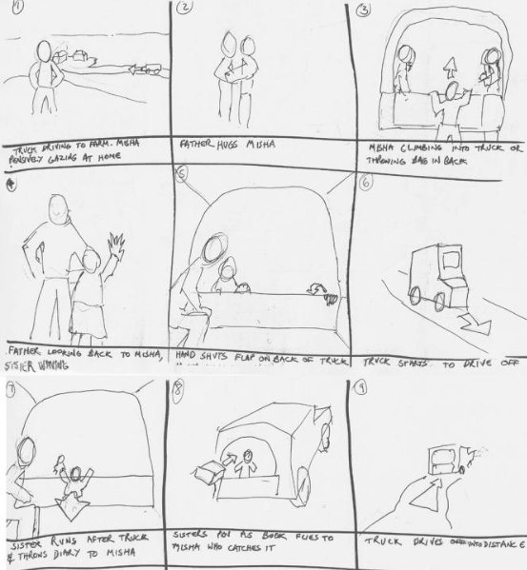

Disclaimer: The European Commission's support for the production of this publication does not constitute an endorsement of the contents, which reflect the views only of the authors, and the Commission cannot be held responsible for any use which may be made of the information contained therein.

This work is licensed under a Creative Commons Attribution-NonCommercial-NoDerivatives 4.0 International License.

